

CCNP Layer 2 Attacks Lab: MAC Flooding, DHCP Starvation, and ARP Spoofing

Assembled by:
Gio Hua
Purpose:
Explore the functions of various Layer 2 Attacks along with their mitigations
Background:
In networking, all switches maintain a MAC table that maps MAC addresses to the switch’s ports. This allows the switch to choose which port it wants to send data out of. MAC (media access control) Flooding is an attack used to compromise the security of switches. It works by purging the preexisting contents of the MAC table out of the switch and forcing unicast flooding behavior. This sends the frames out to all ports within the VLAN, potentially leaking sensitive information to the perpetrator. During the attack, the perpetrator can use a packet analyzer to capture sensitive data transmitted between other computers in the network. Additionally, they may follow up with an ARP Spoofing attack, allowing them to retain the stolen info.
ARP (Address Resolution Protocol) is a communications protocol which resolves internet layer addresses into link layer addresses. ARP Spoofing, also known as ARP cache poisoning or ARP poison routing, is where an attacker sends spoofed ARP messages onto a LAN (Local Area Network). The goal is to associate the attacker’s MAC address with the IP address of another host, which allows them to intercept traffic passing through. They can then modify or stop all traffic. ARP Spoofing is often used to set up other attacks, such as denial of service, man in the middle, or session hijacking attacks. The attack works by exploiting the lack of authentication in the ARP protocol.
A DHCP (Dynamic Host Configuration Protocol) server’s job is to dish out IP addresses to devices on the network. A DHCP IP address allocation transaction depends on four different packets: DISCOVER, OFFER, REQUEST, and ACKNOWLEDGEMENT. When a PC on the network boots up, the server sends a DISCOVER packet to the host. During a DHCP Starvation Attack, the attacker floods a DHCP with fraudulent DISCOVER packets until the DHCP server exhausts its supply of IP addresses. Once the attack is successful, the perpetrator can deny legitimate network users service, or even establish a separate DHCP connection, setting up a Man-in-the-Middle attack.
The data link layer, or layer 2, is the second layer of the seven-layer OSI model of computer networking. This layer is the protocol layer that transfers data between nodes on a network segment across the physical layer. The data link layer provides the functional and procedural means to transfer data between network entities and may also provide the means to detect and possibly correct errors that can occur in the physical layer.
The data link provides for the transfer of data frames between hosts connected to the physical link. Within the semantics of the OSI network architecture, the protocols of the data link layer respond to service requests from the network layer, and perform their function by issuing service requests to the physical layer. That transfer can be reliable or unreliable; many data link protocols do not have acknowledgments of successful frame reception and acceptance, and some data link protocols might not even perform any check for transmission errors. In those cases, higher-level protocols must provide flow control, error checking, acknowledgments, and retransmission.
Lab Commands:
switchport port-security maximum [number-of-addresses] - Sets the maximum number of mac-addresses a port can learn
switchport mode access - Sets the interface to a non-trunking VLAN layer 2 interface
switchport access vlan [vlan-number] - Sets the VLAN the interface operates in for access mode
ip dhcp snooping trust - Configures the specified interface to be a trusted interface. By default, interfaces are not trusted. Usually, interfaces that are configured as trusted are the interface closest to the DHCP server.
switchport port-security - Enables port security on the specified interface
ip dhcp snooping - Enables DHCP snooping globally in the switch

Topology:
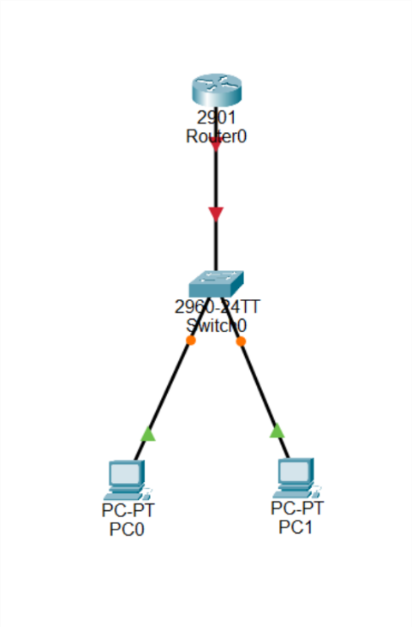
Lab Summary:
This specific lab used Linux Mint, although Linux Distros or VMs (Virtual Machines) are possible alternatives.
First, set up DHCP on a router.
!
hostname R1
!
ip dhcp excluded-address 192.168.1.1 192.168.1.10
!
ip dhcp pool DHCPPOOL1
network 192.168.1.0 255.255.255.0
default-router 192.168.1.1
!
interface G0/0
ip address 192.168.1.1 255.255.255.0
no shut
!
Next, configure your devices ethernet ports to receive IP with DHCP.
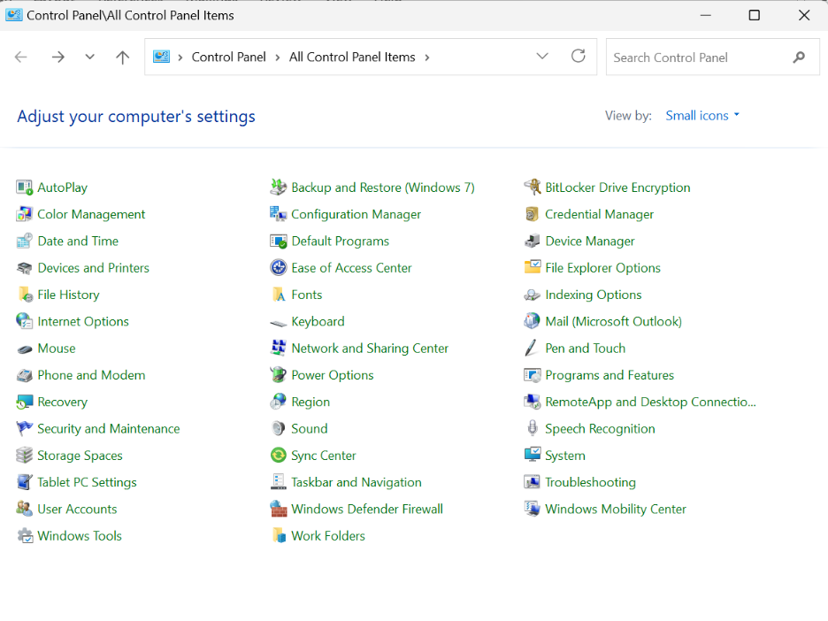
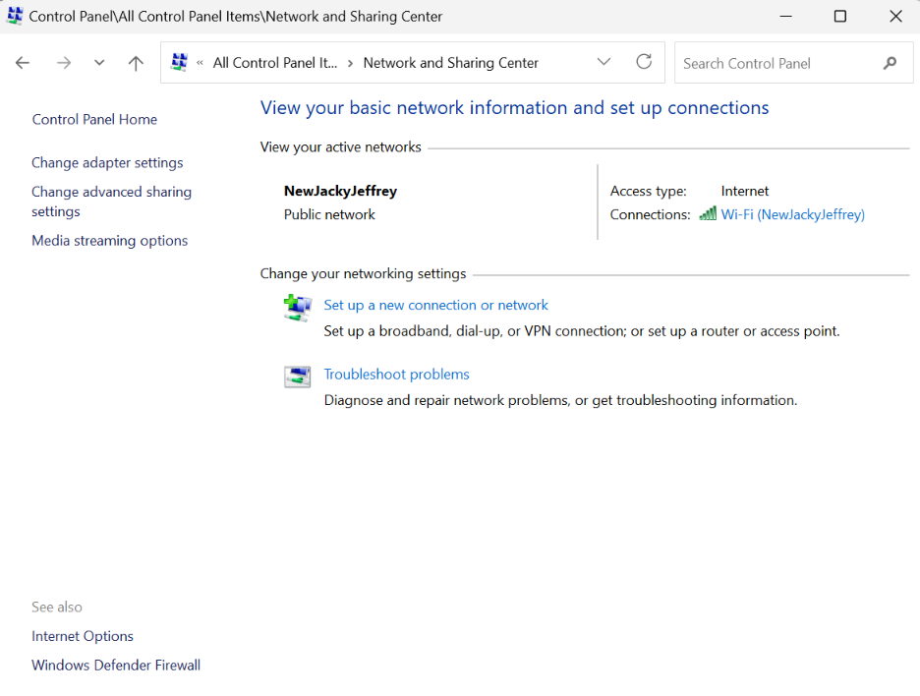
Now you can begin your attacks!

MAC Flooding (Execution):
Inside Linux, open terminal and install DSniff with the command:
~$ sudo apt install dsniff
Next, to flood MAC addresses, use the command:
~$ sudo macof
Or
~$ sudo macof -i eth0 (or whatever interface)
Traffic is now flooding throughout the port, or all ports if not specified. Use WireShark to view the attack. Check the CAM table to see the MAC addresses bound to the switch.
During the MAC flooding process, when the victim PC pings the router, the attacking PC should be able to see the packets captured in their PC without any connections to the victim PC.
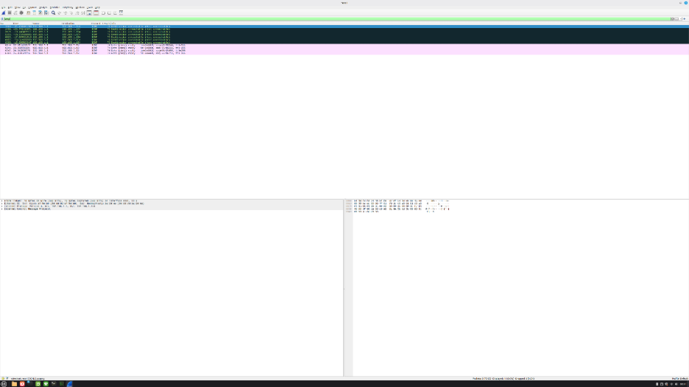
MAC Flooding (Mitigation):
MAC Flooding has an easy counter: Port Security. Begin by configuring Port Security on all ports on the switch. The commands are listed below:
hostname S1
!
int fa0/1
switchport mode access
switchport port-security
switchport port-security maximum 5
switchport violation shutdown
!
ARP Spoofing (Exection)
Inside Linux, open terminal and install DSniff.
~$ sudo apt install dsniff
Next, configure port forwarding.
~$ sudo sysctl -w net.ipv4.ip_forward=1
Next, to execute the attack.
~$ sudo arpspoof -i eth0 (interface) -t 192.168.1.13 (Victim PC IP) 192.168.1.1 (Default Gateway IP)
*Use CTRL-C to stop the attack. Use WireShark to view the attack.

Before and during the attack, check the ARP table using
arp -a
The MAC address on the default gateway should change before and after the attack. You should not be able to ping the default gateway after the attack.
ARP Spoofing (Mitigation):
To prevent ARP spoofing, configure ARP inspection and DHCP Snooping on the switch, untrusted on unused ports or ports with needed security and trusted on reliable ports:

hostname S1
!
ip dhcp snooping
ip arp inspection
int fa0/1 (trusted port)
ip dhcp snooping trust
ip arp inspection trust
!
int fa0/2 (untrusted port)
!
DHCP Starvation (Execution):
Inside Linux, open the terminal.
Install DSniff with the command:
~$ sudo apt install yersinia
After it is installed, run the following:
~$ sudo yersinia -I
It should reveal yersinia’s interactive mode.
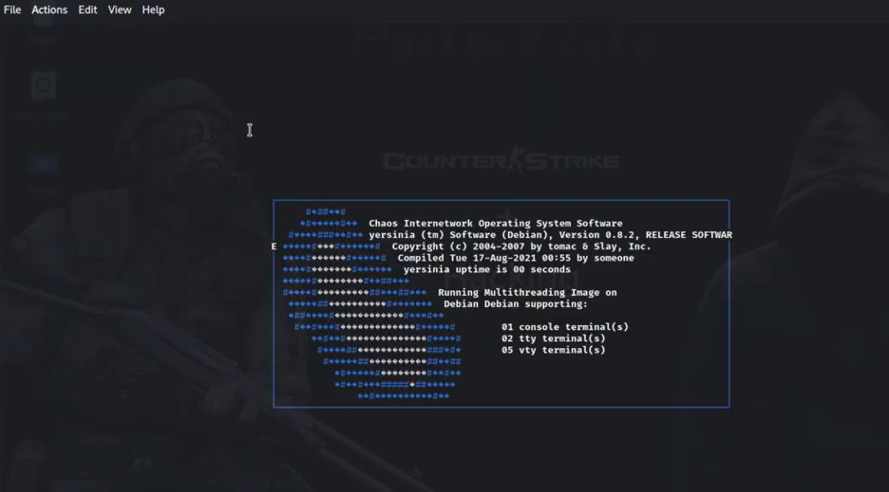
Press h to view command screen.
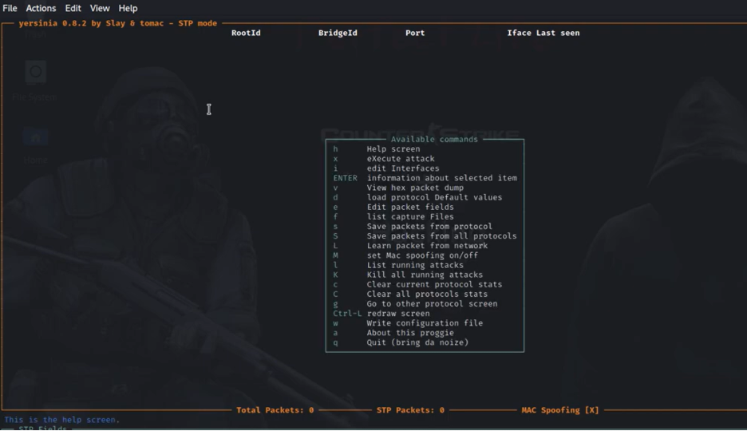
Press g to view all the available protocols.
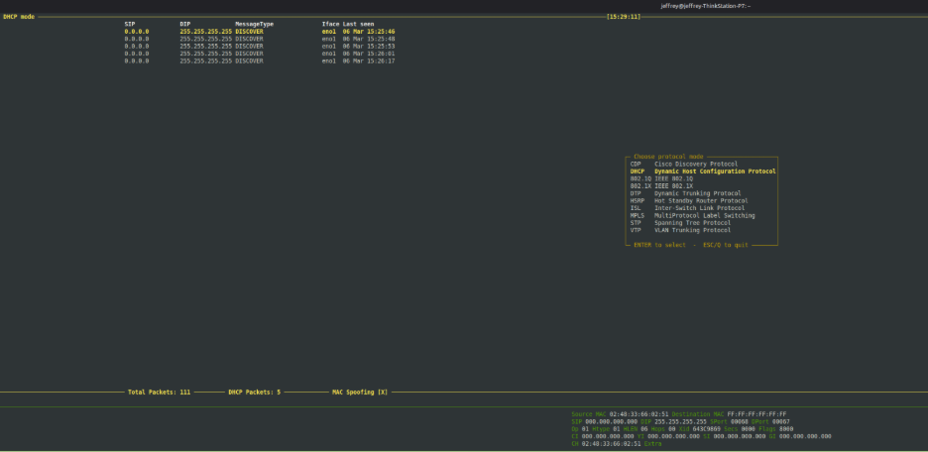
Choose DHCP Starvation to start to attack.
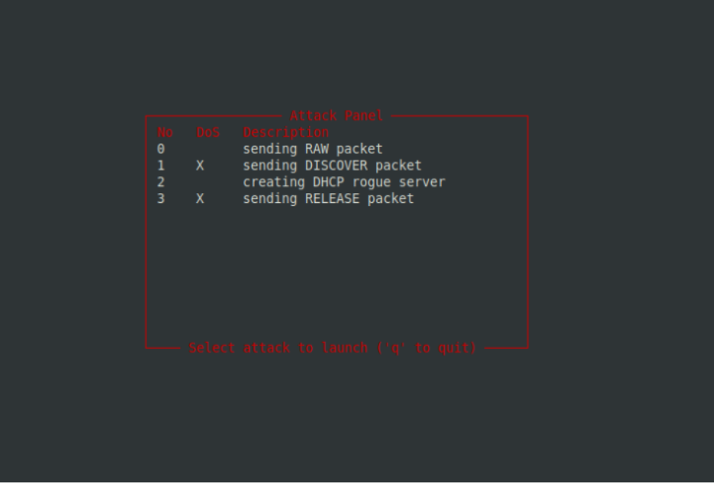
Packets should start flooding through Wireshark. You can also view the amount of DHCP addresses exhausted using this command in router:
show dhcp binding

It should pop up a screen similar to this:


DHCP Starvation (Mitigation):
To counter DHCP Starvation, configure Port Security, ARP inspection, and DHCP snooping on the switch:

hostname S1
!
ip dhcp snooping
ip arp inspection
!
int fa0/1 (Trusted port)
switchport mode access
switchport port-security
switchport port-security maximum 5
switchport violation shutdown
ip arp inspection trust
ip dhcp snooping trust
!
int fa0/2 (Untrusted port)
switchport mode access
switchport port-security
switchport port-security maximum 5
switchport violation shutdown
!
*After running the attack, the port should enter err-disabled state. Shut down and no shut to enable it.

Problems:
We initially tried to use VMware to simulate the attacks, but ran into numerous issues:
- Had to be run through a bridged setting (connected to a physical topology not a simulated one)
- Cursor would disappear occasionally despite multiple resets
- VMware becomes extremely laggy when running commands
- Limited storage on Wireshark when tracing packets (allocate more space)
Additional Problems:
- While running Port Security, it is important to check on the switch after an attack and reset the ports in case they are in err-disabled mode
- Trusted ports need to be manually set while running ARP inspection and/or DHCP snooping, otherwise traffic will not go through
- When doing general configurations, problems as simple as faulty cabling can occur. Make sure you check your topology for issues.

Conclusion:
It was surprisingly enjoyable setting up and launching the attacks. Although VMware was a pain to use, Yersinia kept things straightforward and we eventually persevered to the finish.

